Internship Report – Day 4

Objective
To review manufacturing processes, understand 3D printing workflows and constraints, perform calibration runs, and create a logo using Inkscape.

Common 3D Printing Filaments
- PLA (Polylactic Acid)
  - Most widely used beginner filament.
  - Easy to print, low warping, biodegradable.
  - Not very heat-resistant.
- ABS (Acrylonitrile Butadiene Styrene)
  - Stronger and more heat-resistant than PLA.
  - Requires enclosed printer (warps easily).
  - Emits fumes — ventilation needed.

01

Review Manufacturing Processes
Understand subtractive, formative, and additive methods.
- Subtractive: milling, turning, grinding (material removed)
- Formative: molding, casting (material forced into shape)
- Additive: 3D printing, layer-by-layer deposition

02

Compile Machine Axis Conventions
Document axis roles for CNC, lathe, laser cutter, robotics.
- X/Y: horizontal plane
- Z: vertical motion
- A/B/C: rotations about X/Y/Z
- Lathe: Z = feed, spindle rotation = C axis

03

Set Up Slicing Software
Prepare STL files for 3D printing.
- Import CAD model
- Select filament type & color
- Configure layer height, infill, supports

04

Perform Calibration Runs
Verify dimensional accuracy of prints.
- Test tolerances from 0.1 mm to 3 mm
- Adjust slicer settings (layer height, extrusion multiplier)
- Document calibration curves

05

Report Material Limitations
Summarize constraints of ABS, EPS, APS.
- ABS requires enclosed chamber
- EPS needs controlled environment
- Printable thickness: 0.1 mm – 3 mm
- Overhangs > 45° need supports

Overhanging Print Experiment
- Designed a test model with overhangs to study support requirements.
- Observed that angles > 45° needed slicer-generated supports.
- Calibration showed tolerances within 0.2 mm for supported sections.
- Unsupported overhangs sagged, confirming design-for-manufacturing rules.

Design for Manufacturing (DfM) Considerations
- Follow ISO standard dimensions for shafts/holes/tolerances
- Minimize overhang angles > 45° to reduce supports
- Account for shrinkage and post-process deformation
- Validate part geometry in design database before printing

Outcome
- Gained practical insight into overhang limitations in 3D printing.
- Verified calibration tolerances (0.1–3 mm).
- Documented material constraints and support strategies.
- Created a logo in Inkscape for portfolio branding.
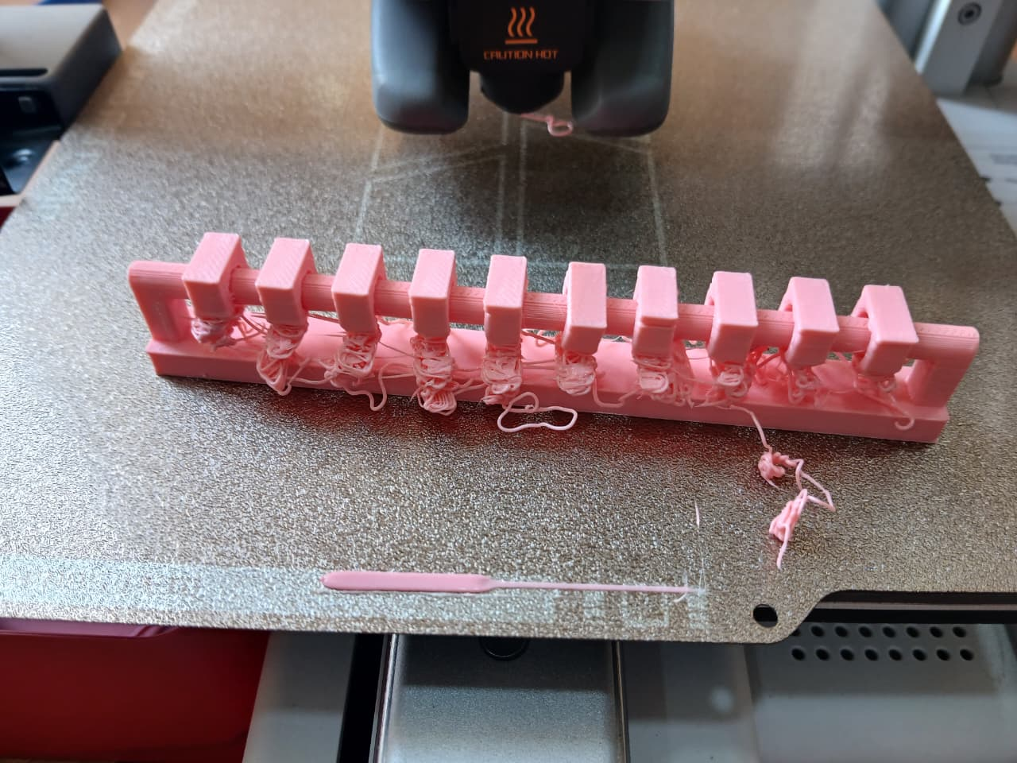
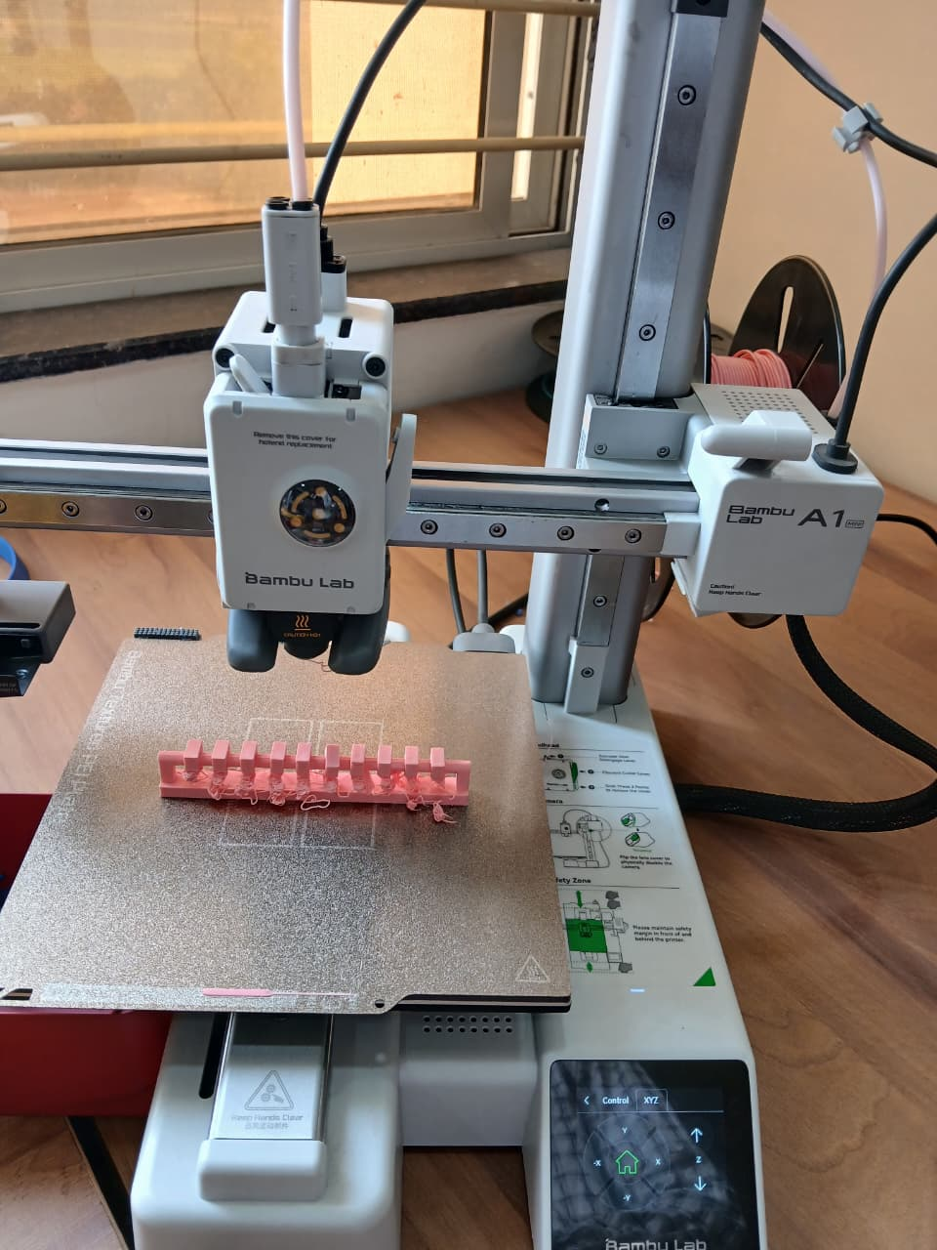

Calibration Boat Experiment

Purpose
We printed a calibration boat (benchy) to evaluate the 3D printer’s performance in handling overhangs, bridges, surface finish, and dimensional accuracy.

Step 1: Sketch / CAD Model
- Began with the standard Benchy STL file, which is a calibration boat model designed to test 3D printer performance.
- Verified dimensions in CAD software to ensure the model matched the intended calibration size (≈60 mm length).

Step 2: Slicing Setup
- Printer: Bambu Lab A1 Mini
- Nozzle Diameter: 0.4 mm
- Filament: Generic PLA
- Process Profile: 0.20 mm Standard @BBL A1M
- Bed Adhesion: Brim, width 5 mm, gap 0.1 mm
- Prime Tower: Enabled, width 35 mm, max speed 90 mm/s
- Slicing Result:
  - Filament length: 4.11 m
  - Filament weight: 12.26 g
  - Estimated cost: ₹0.25 (approx)
  - Print time: 53 minutes 5 seconds
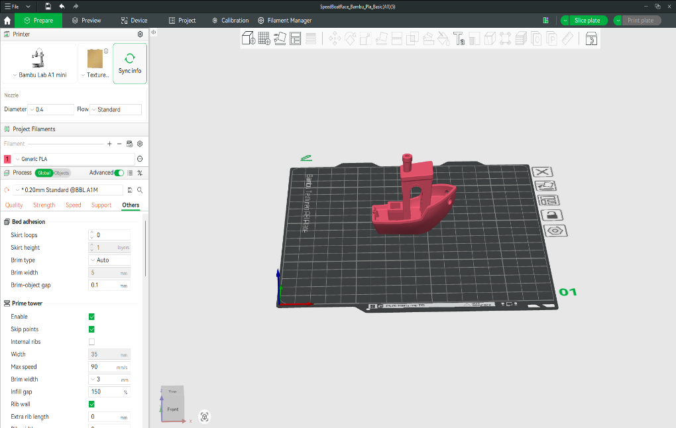

Object Details (from slicer):
- Name: SpeedBoatRace_Bambu_Pla_Basic(A1)(5).stl
- Size: 60.027 × 31.0049 × 48 mm
- Volume: 15,550.4 mm³
- Triangles: 225,154

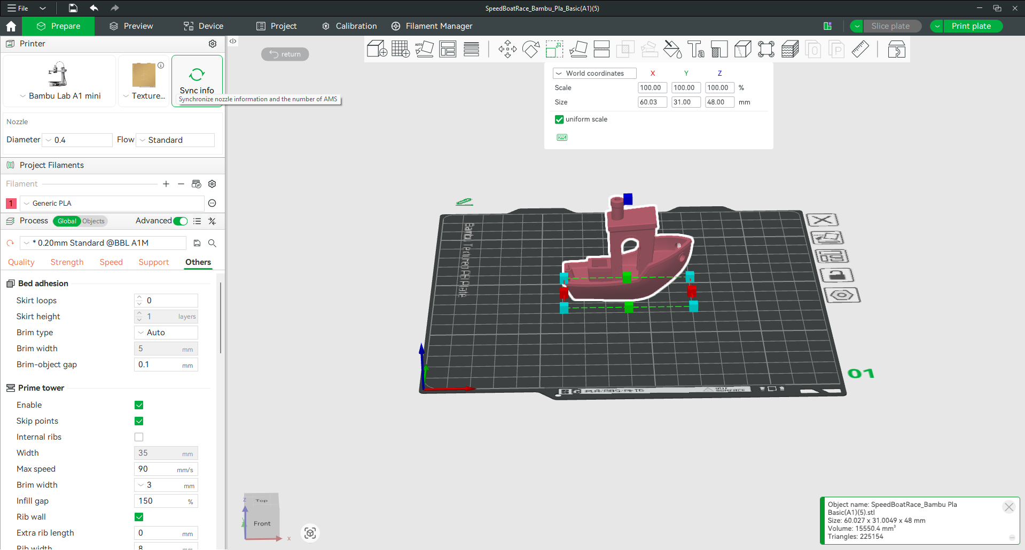

Step 3: Printing
- Loaded PLA filament into the printer.
- Ran the print with calibrated nozzle and bed leveling.
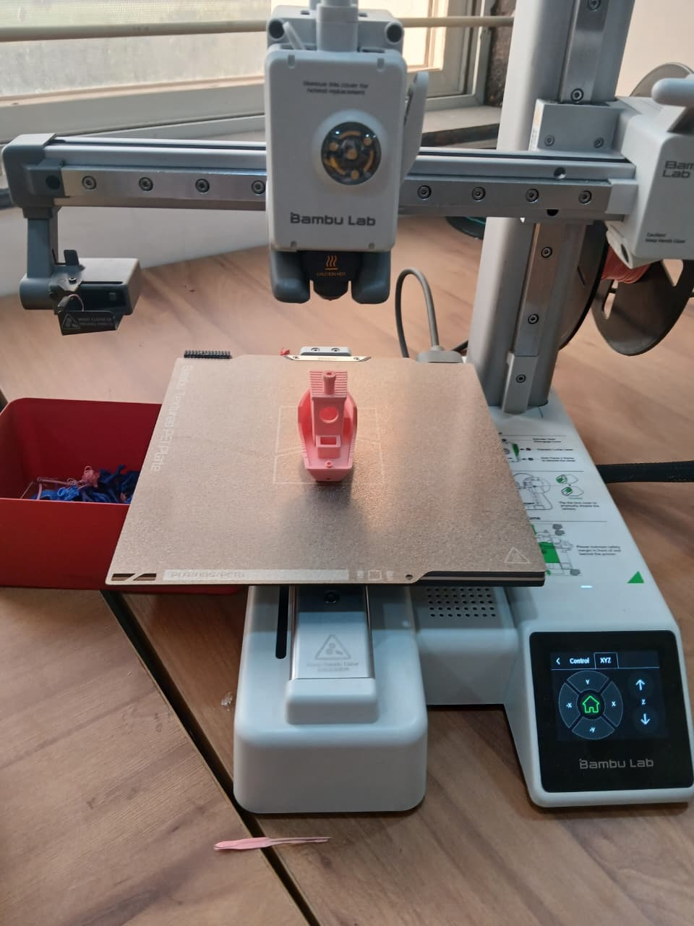
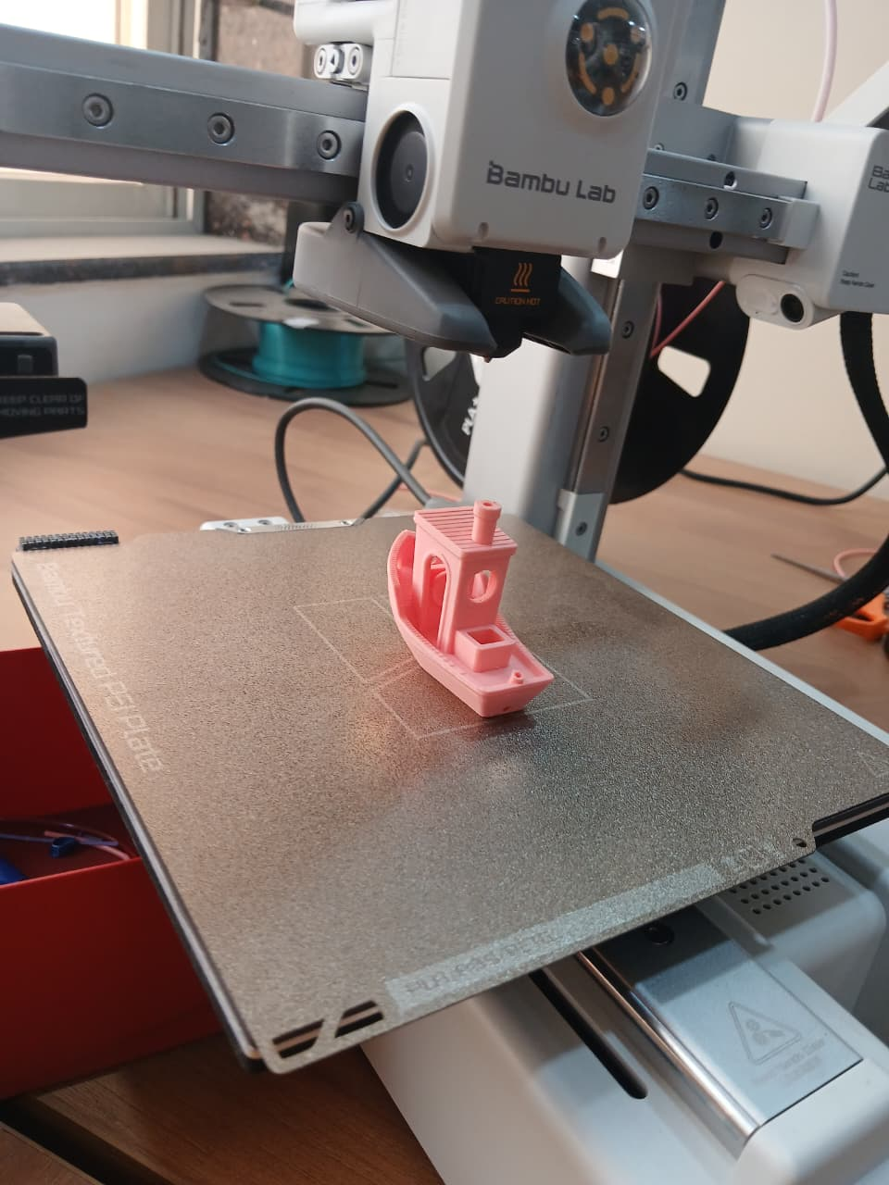
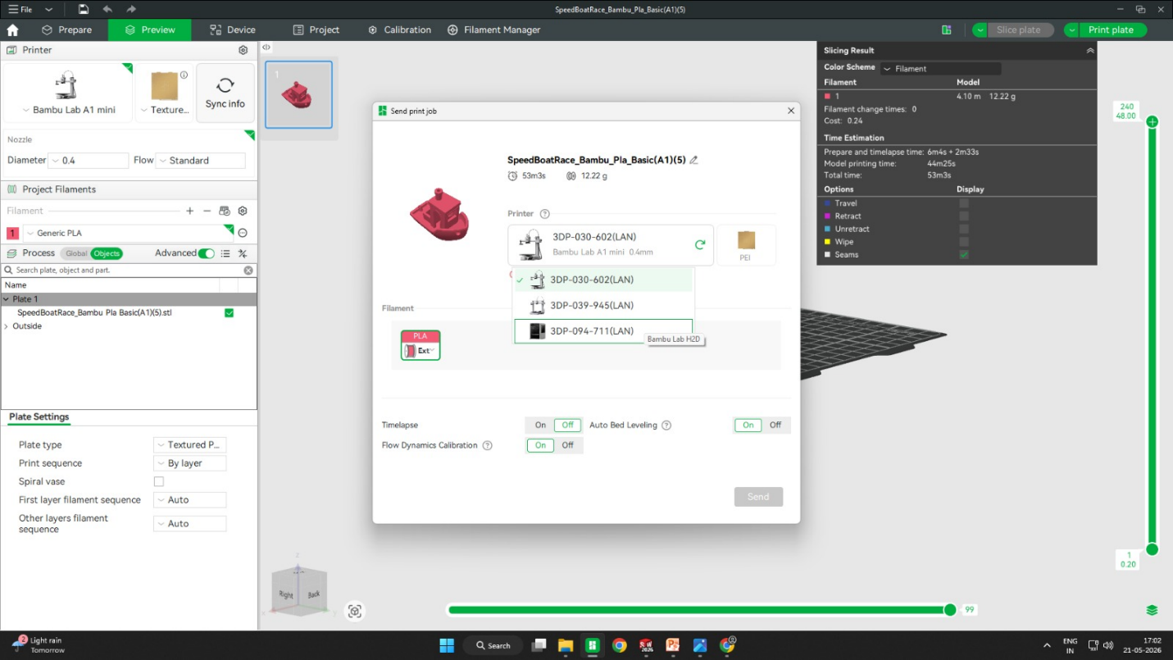
- Observed hull curves, cabin roof, and chimney overhangs during printing

Outcome
- Verified printer calibration and slicing settings.
- Documented filament usage, print time, and dimensional accuracy.
- Confirmed printer can handle complex geometries, bridges, and overhangs with supports.
Logo Design with Inkscape

Step 1: Starting the Logo Project
- Opened Inkscape and created a new document.
- Decided to design a simple logo for “Tinkerers Lab”.
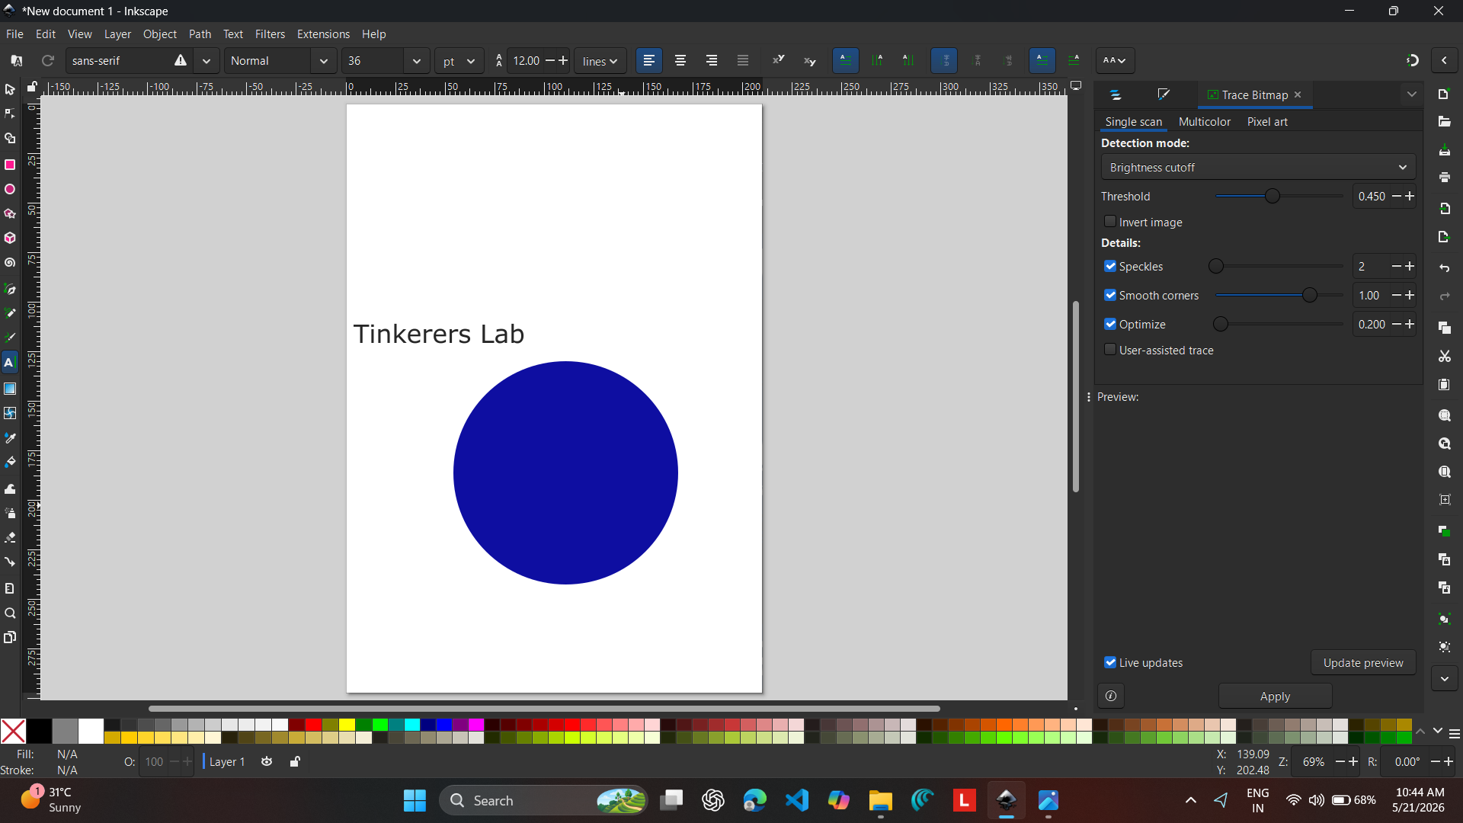

Step 2: Adding Shapes & Text
- Created a thick blue ring with a black outline to form the base of the logo.
- Added curved text along the ring:
  - Top: “TINKERERS LAB”
  - Bottom: “INTERN”
- Used bold white capital letters for clarity and contrast.

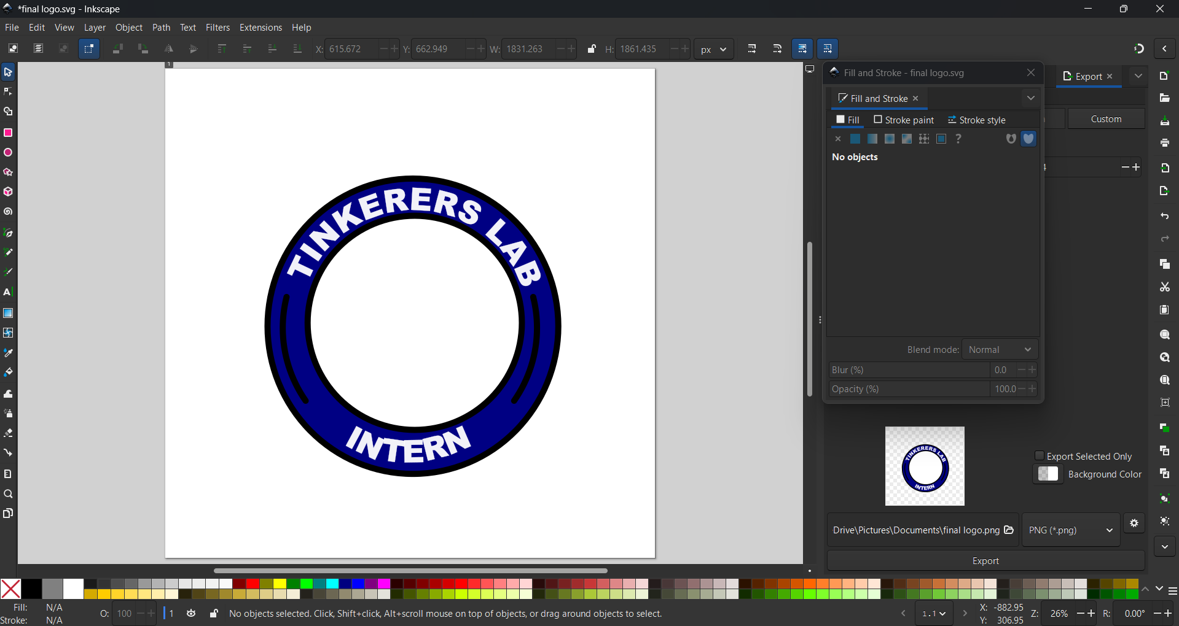

Step 3: Adding the Logo Elements
- Imported emblem graphics into Inkscape.
- Combined them with the circular badge design created earlier.
- Added text:
  - Top curve: “TINKERERS LAB”
  - Bottom curve: “INTERN”
- Placed the Sanjivani University emblem inside the circle for institutional identity.

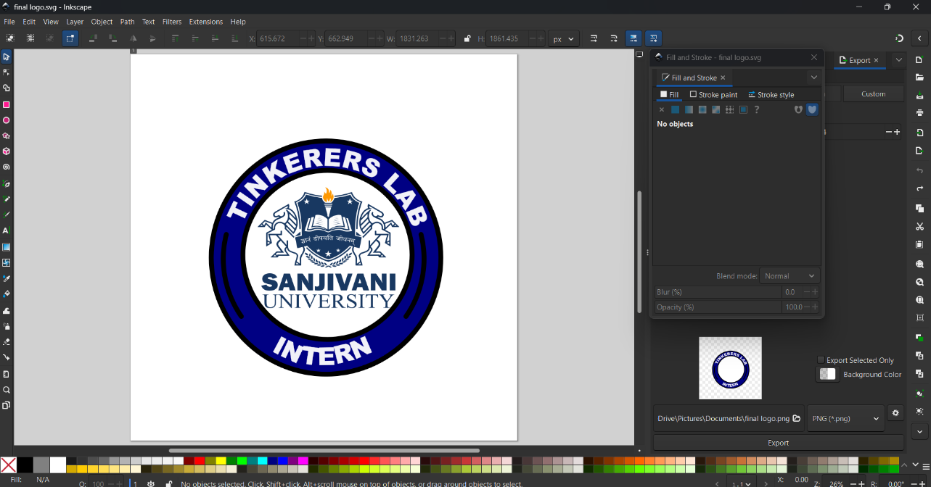

GitHub Integration-

Step 1: Editing the Project
- After completing the logo design in Inkscape, I made refinements to the file (adjusted text alignment, colors, and emblem placement).
- Saved the updated version in both SVG (editable) and PNG (for documentation).

Step 2: Preparing for GitHub
- Opened the local project folder containing the internship assets.
- Added the updated logo file to the repository.
- Used Git commands to stage and commit changes:
bash
git add logo.png logo.svg
git commit -m "Updated Tinkerers Lab Intern logo"

Step 3: Pushing to GitHub
- Connected to the remote repository.
- Pushed the changes:
bash
git push origin main
- Verified that the updated logo appeared in the GitHub repository.

Outcome
- Successfully integrated design changes into version control.
- Ensured that the updated logo is now accessible in the GitHub repository for collaboration and documentation.
- Demonstrated the complete workflow: design → edit → export → commit → push → share.

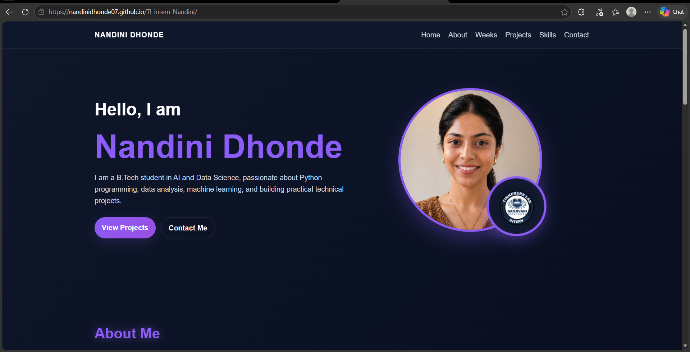

Conclusion
Day 4 marked a significant milestone in my internship journey. I combined theoretical learning (manufacturing processes, machine axes, material limitations) with hands-on practice (3D printing calibration boat, overhang test, and slicer calibration). On the creative side, I designed and finalized a professional logo in Inkscape, exported it as PNG, and integrated it into my project. Finally, I practiced version control by pushing updates to GitHub, ensuring my work is documented, shareable, and collaborative.
This day highlighted the importance of precision, creativity, and documentation in technical projects. By bridging engineering workflows with design and GitHub integration, I strengthened both my technical and creative skill sets. Moving forward, these experiences will serve as a foundation for more complex tasks in the internship.

